1. Quiz page

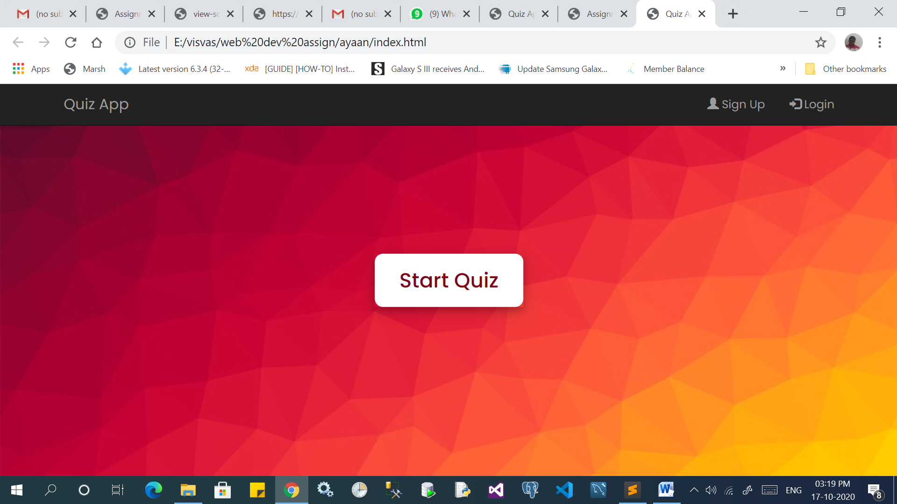

1. Login page

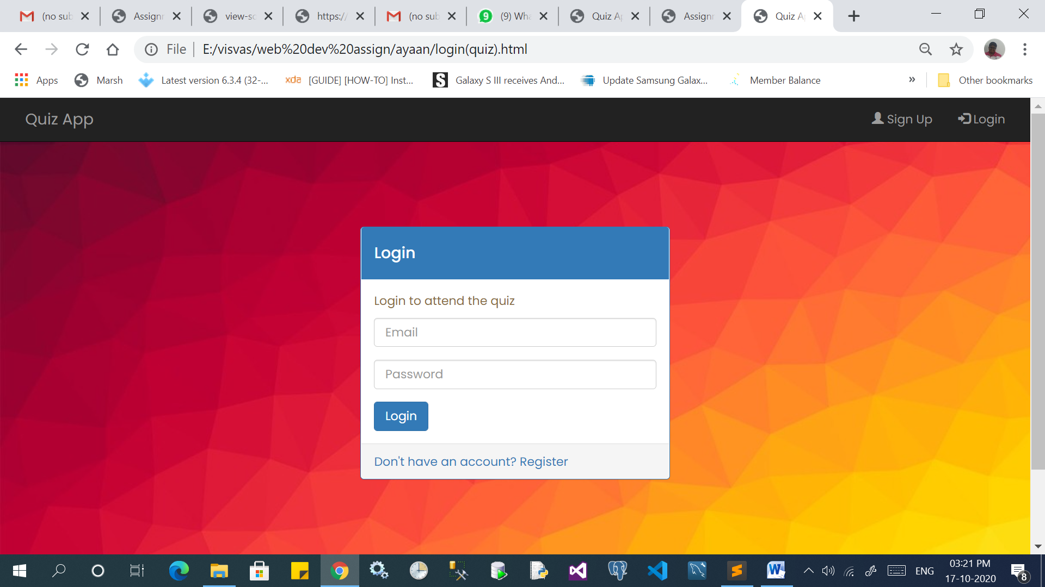

3.Sign up page

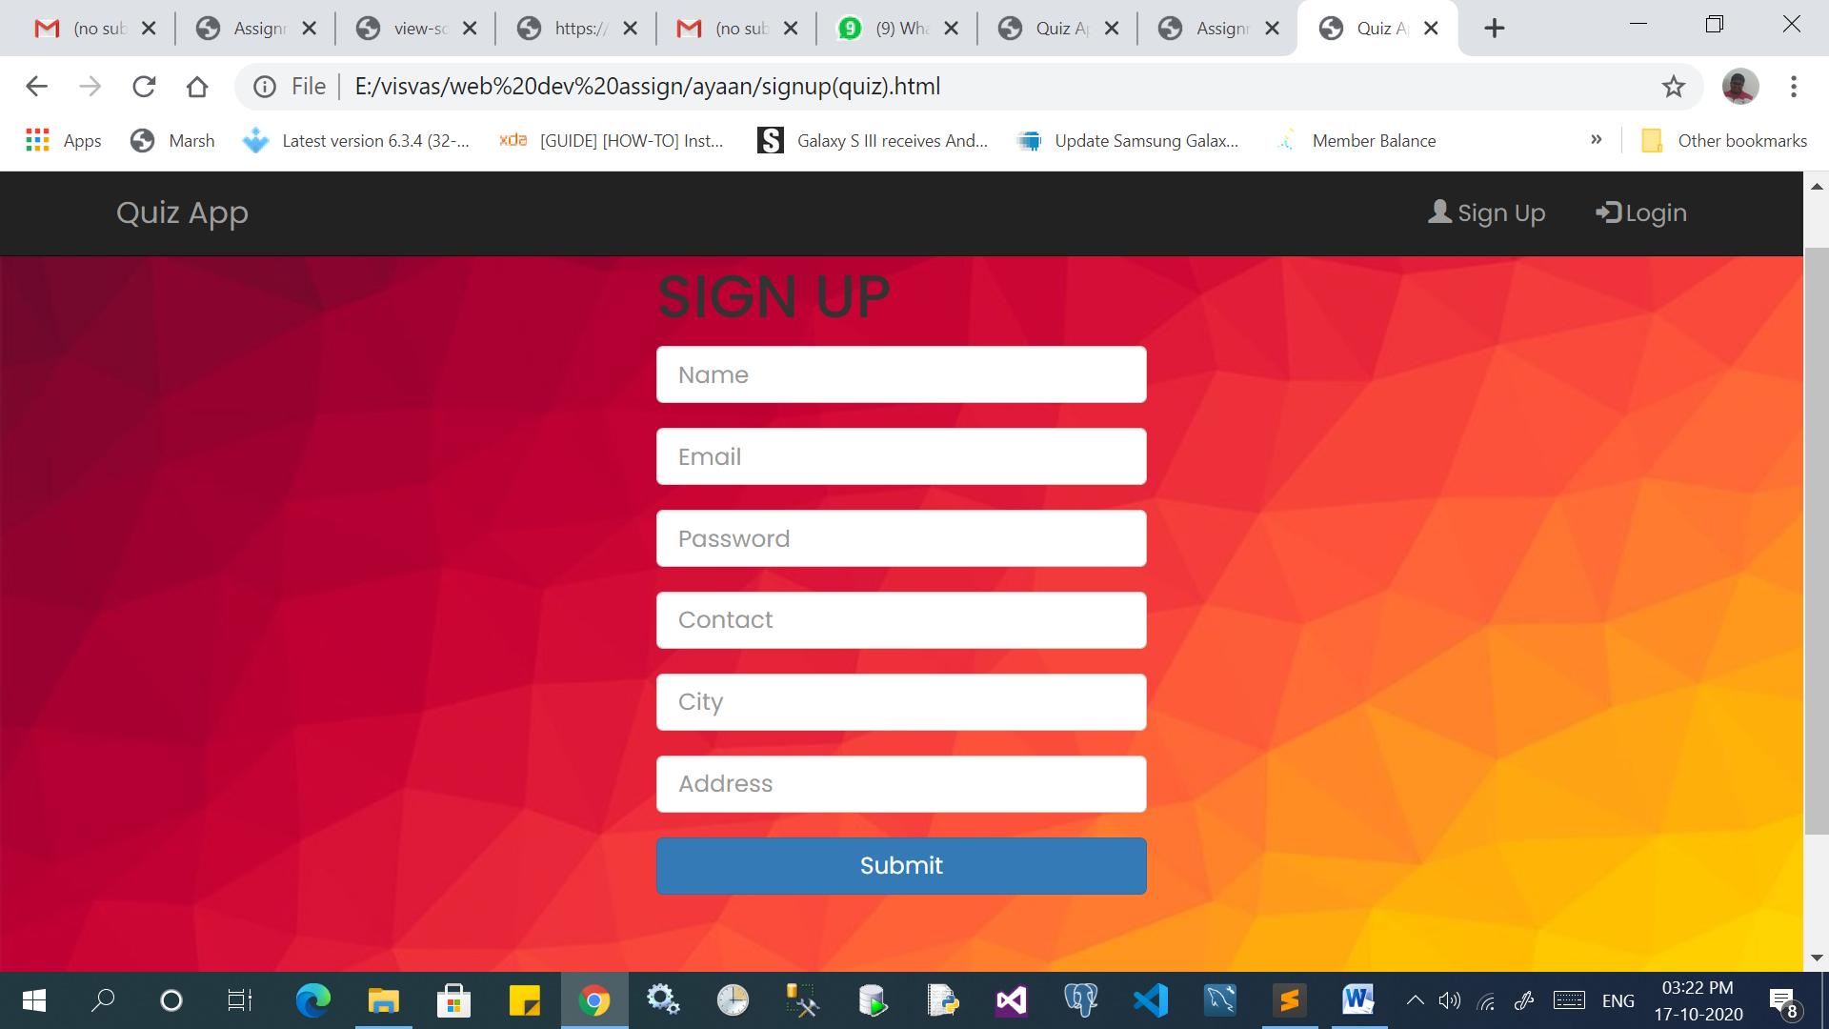

List of fields used in sign-up page:

* **Text-Field:**  These fields are used to get the input from the user. The fields used here are for name,email,password,contact,city and address.
* **Button:** This button is used to submit the details of the new user to the admin of the application. After validation, it’ll get submitted to the database.

List of fields used in login page:

* **Text-field:** The fields used here are for entering the user’s email and their password.
* **Button:** This button is used to verify the credentials of the user. After validation and verification, the user will get access to the quiz.

List of fields used in quiz app:

* **Buttons:**  Buttons are being used for navigation throughout the application. Various types of button used are:
  + **Start quiz –** used to start the quiz
  + **Exit Quiz –**used when the user wants to quit the quiz.
  + **Continue –** used when the user agrees to the rules and starts attending the quiz.
  + **Next Que** – used when the user has attended a question
  + **Restart**  **Quiz –** used when the user wants to attend quiz again
  + **Quit quiz –** used when the user doesn’t want to play the quiz again.
* **Timer:** The timer is used where the user gets 15 seconds to attend each question.
* **Notification:** This is used to notify the user about the details of the quiz.
  + Rules – The user is notified of the rules of the quiz as they click the start quiz button.
  + Green highlight/tick – this is used when the user gets a correct answer. It is also shown where the user has got an incorrect answer.
  + Red highlight/cross – this is used when a user gets a wrong answer
  + Score: this is used when the user has completed the quiz and is notified of their score.
* **Common fields:**
  + **Navigation bar:**  used for easier navigation